***KodeKloud***

**Project:**

KodeKloud is an e-commerce application which sells electronic devices online. 

Our website is built on **LAMP Stack. **Deploy on Linux (CentOS) with Apache Server that uses MariaDB (It is a community fork of MySQL) and the PHP Programming language.

**Steps to do:** 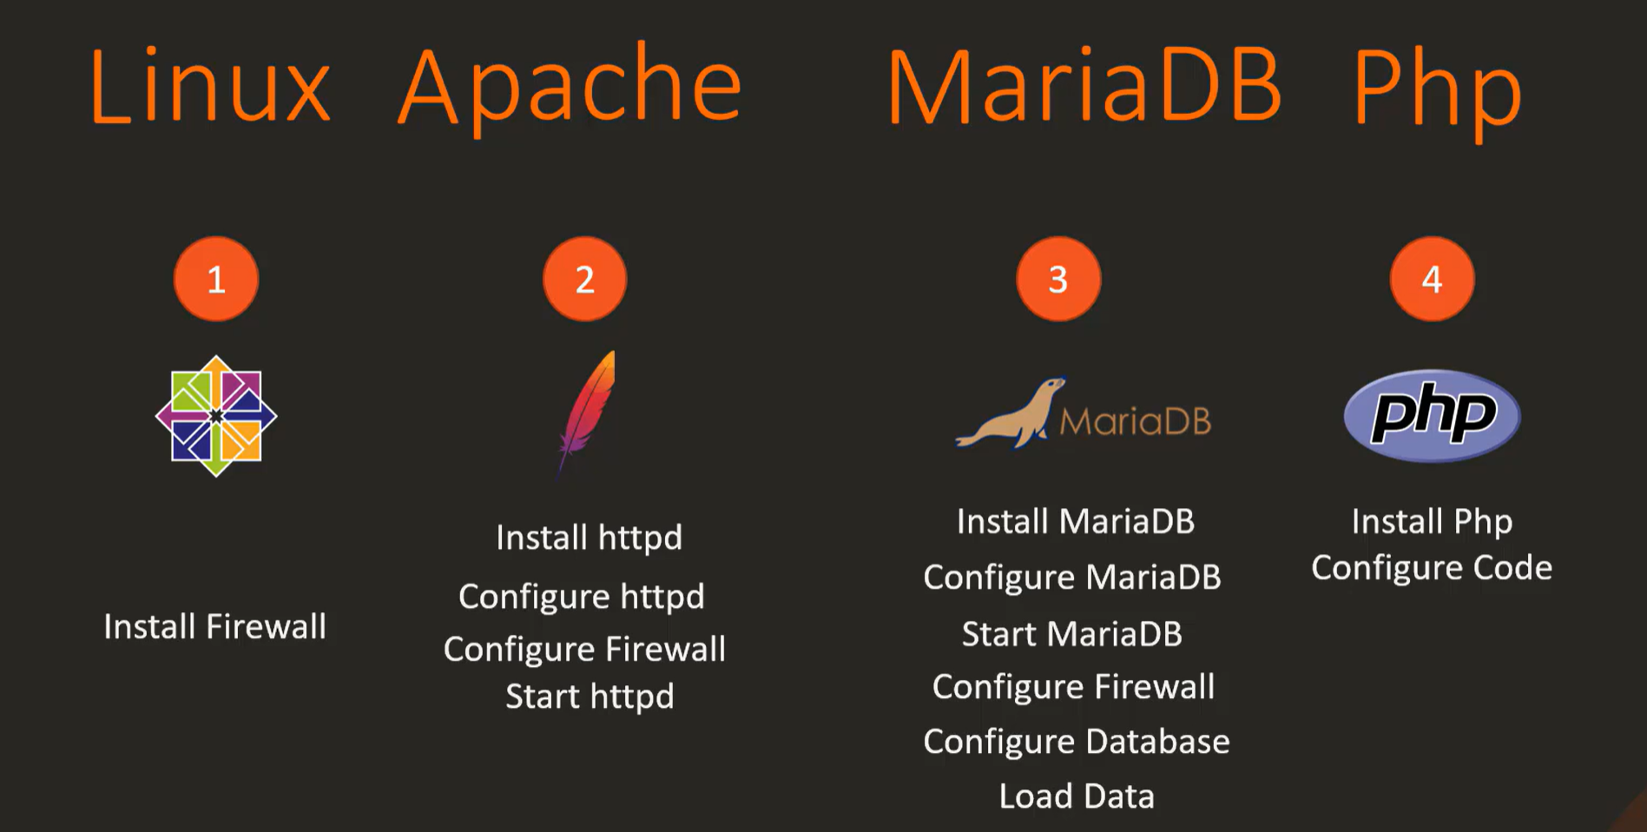

**Step – 1:** Identify a system on which we will deploy this application. It’s Linux – CentOS Machine.

**Step – 2:** Install and configure Apache httpd server. Enable and start the service.

**Step – 3:** Install and configure MariaDB. Enable and start services.

**Step – 4:** Install and configure php on the serer. Download the source of the app and configure it to work with apache and php.

By rearranging the steps in order: 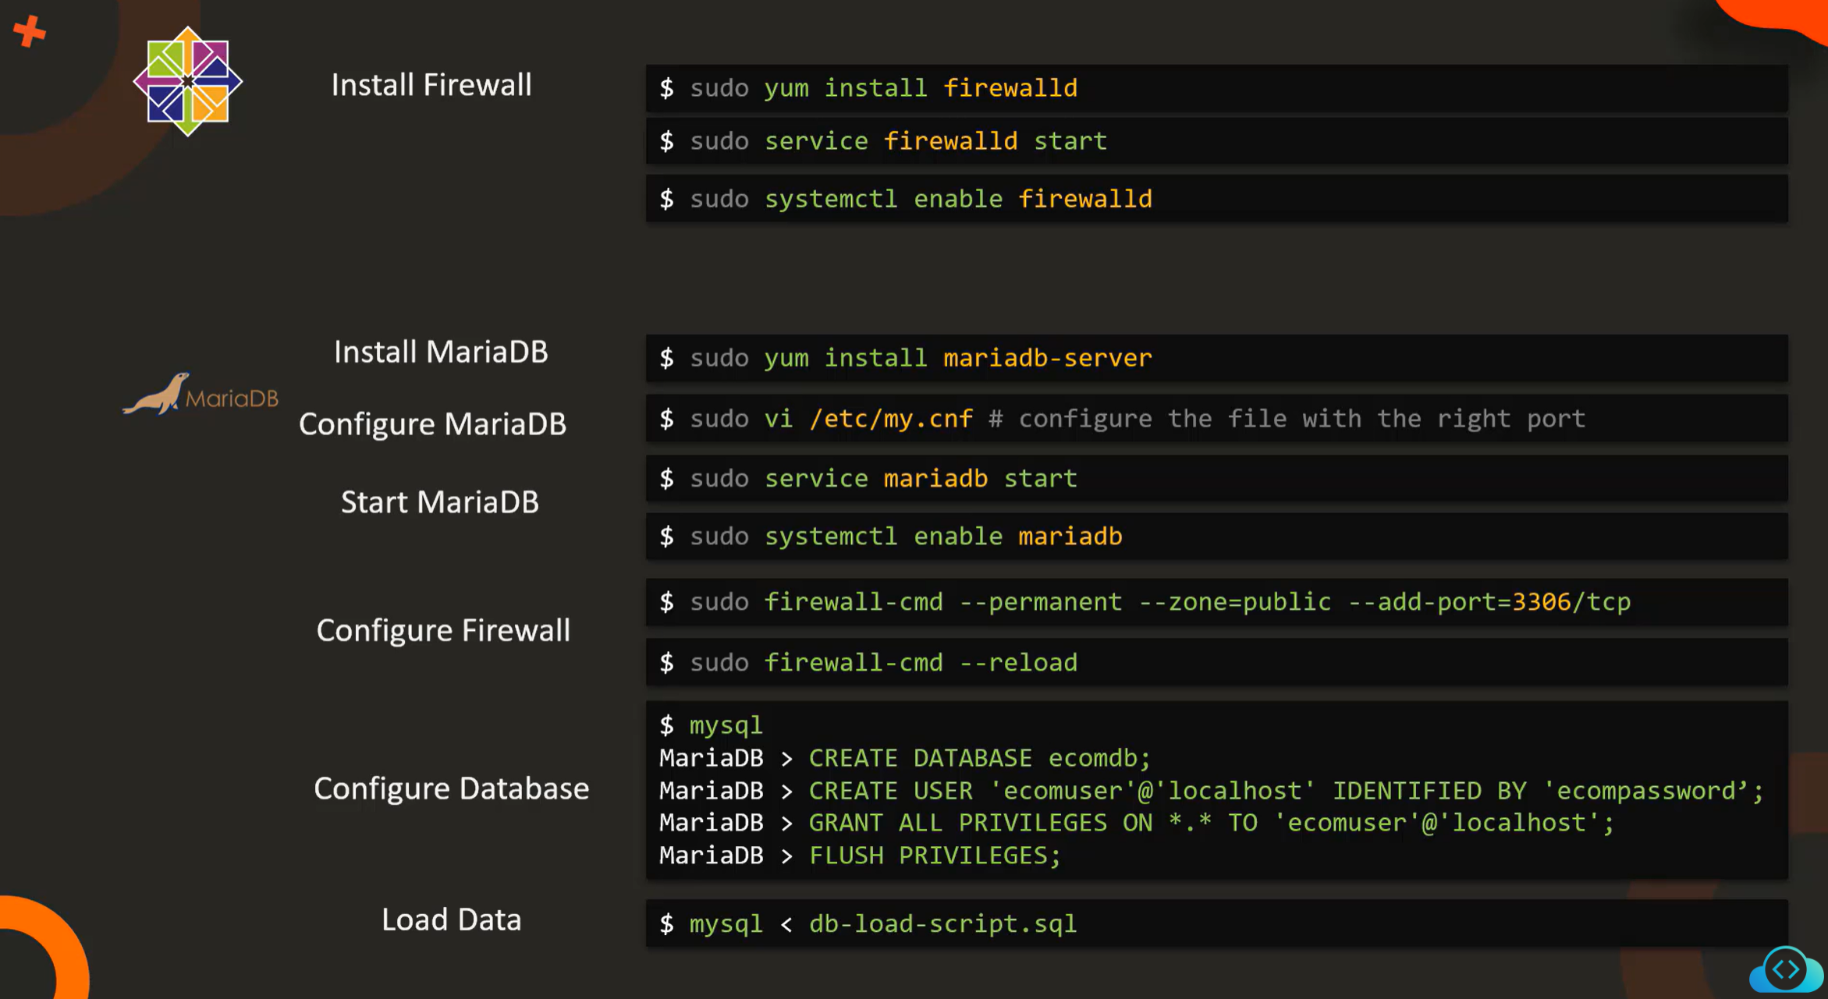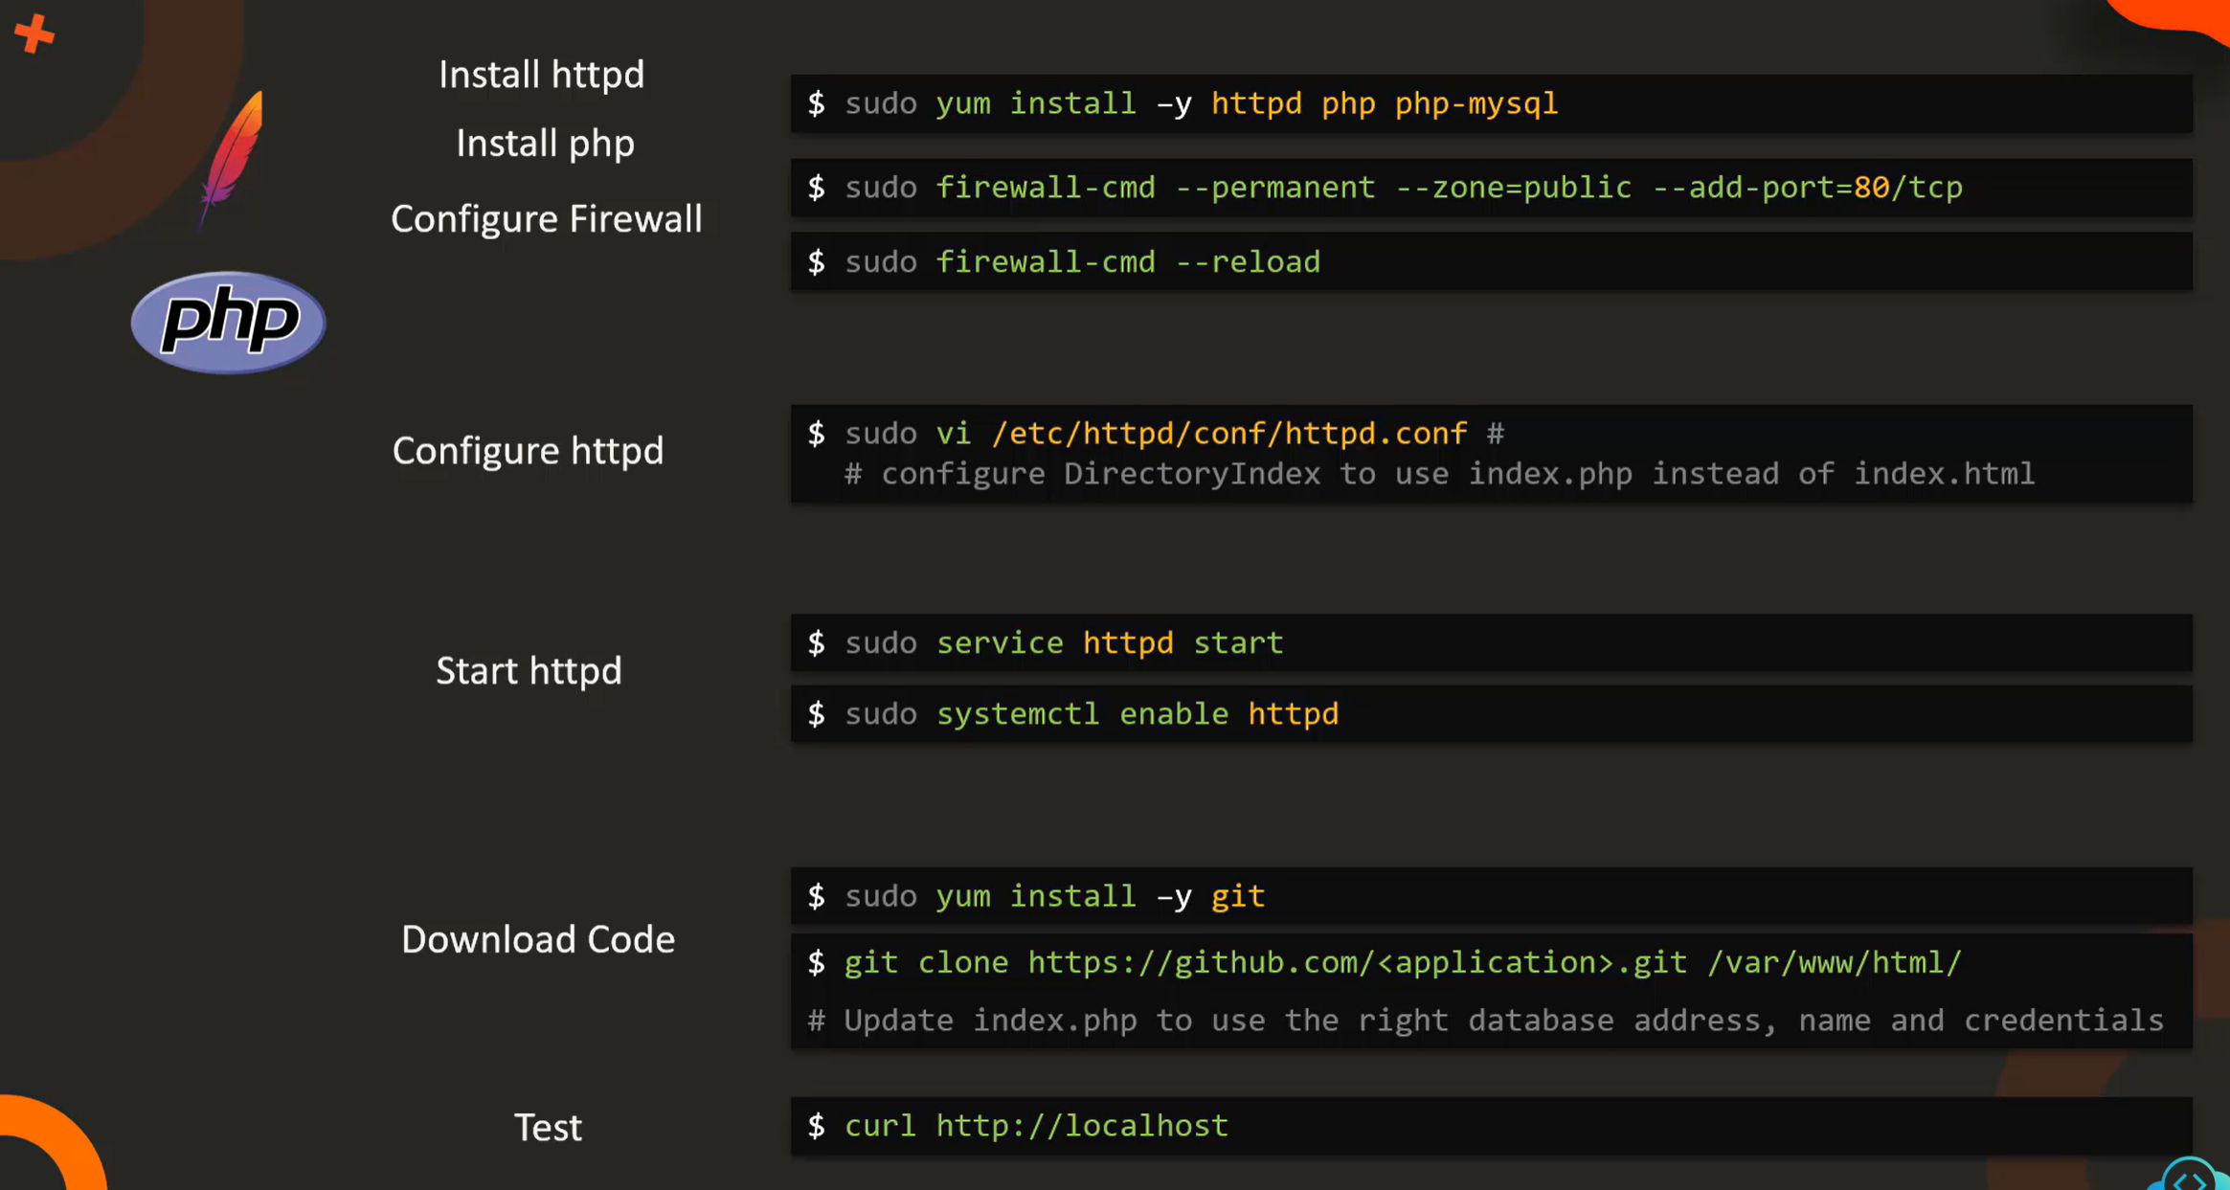

**Deployment Model:** We are deploying this LAMP stack application in single node meaning MariaDB, Apache, PHP will be in same node. In multi-node setup we will deploy them separately. 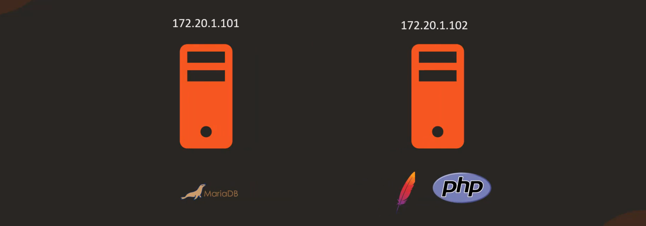

In multi – Node deployment we need to configure both DB server and index.php file on the web server with the IP address of DB server. Similarly while configuring the DB server with user add the IP address of web server.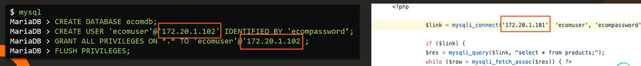

In the whole HTML code, we no need to know anything about HTML. We have to know only about this line: 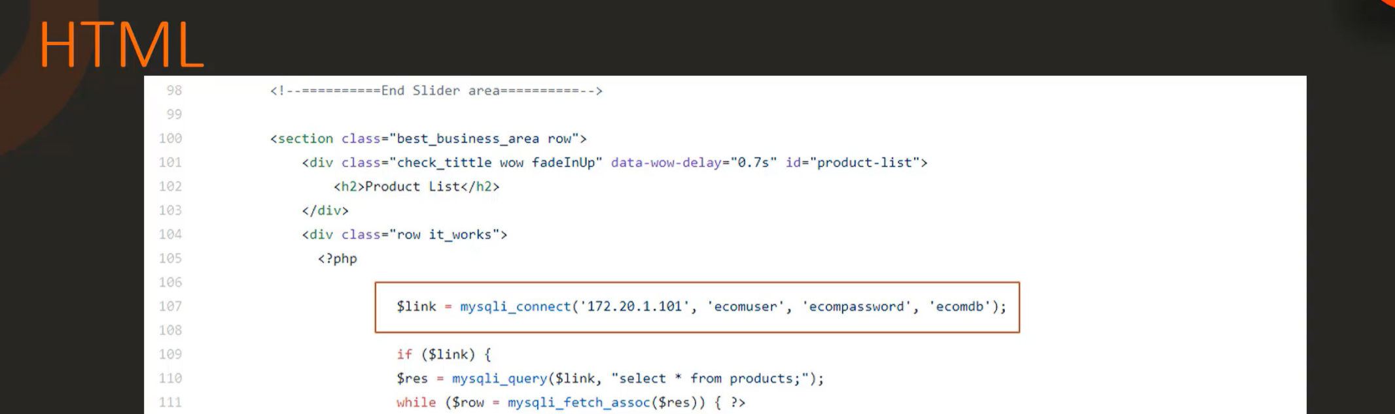

**Project Starts:**

**Deployment Model – Single Node**

CentOS AMI is not available in AWS. So, created a CentOS playground for in KodeKloud for this project.

**Step – 1: Installing FirewallD**

**Commands:** sudo yum install -y firewalld 🡪 sudo systemctl start firewalld 🡪 sudo systemctl enable firewalld 🡪 sudo systemctl status firewalld

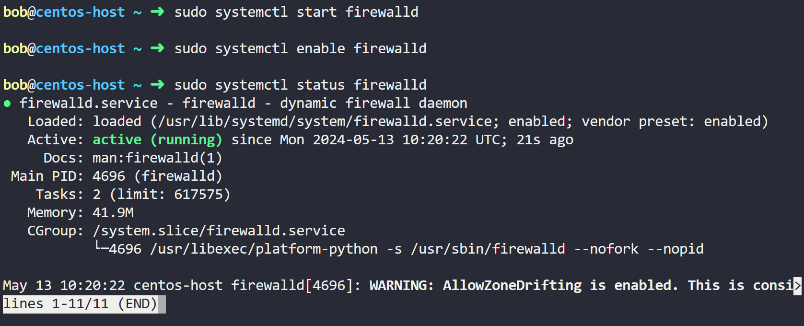

To check the list of firewall rules use **firewall-cmd --list**

So later when we have to configure the urles we will make sure to use those commands to make sure the rules are in place.

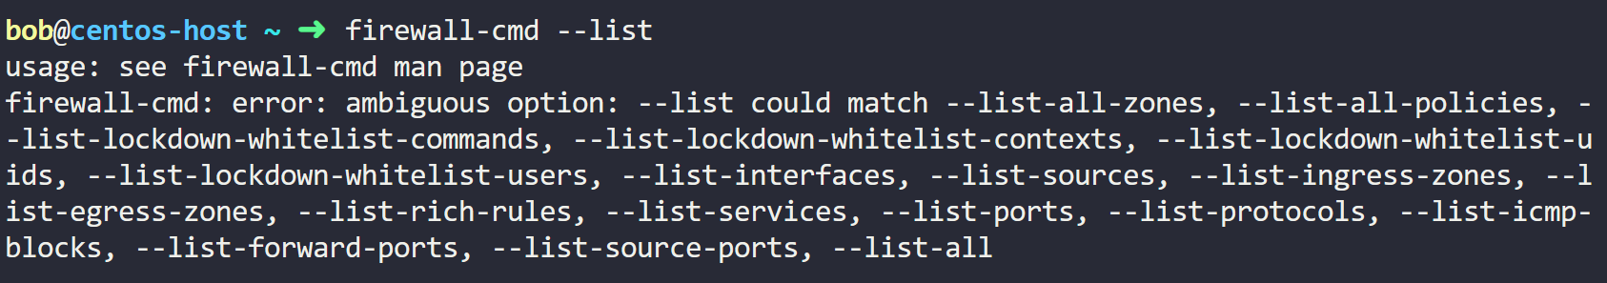**Step – 2: Installing, Starting and Enabling MariaDB Services:**

**Commands:**

sudo yum install -y mariadb-server

sudo vi /etc/my.cnf (We are going with default. So, No need to change and run this command.)

sudo systemctl start mariadb

sudo systemctl enable mariadb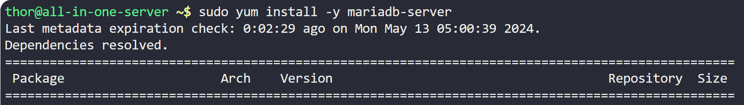

**Steps – 3: Configuring Firewall rule for Database.**

**Commands:** sudo firewall-cmd --permanent --zone=public --add-port=3306/tcp 🡪

sudo firewall-cmd --list-all (Checking rules – Port won’t be added. Have to reload and then check) 🡪

sudo firewall-cmd --reload 🡪 sudo firewall-cmd --list-all

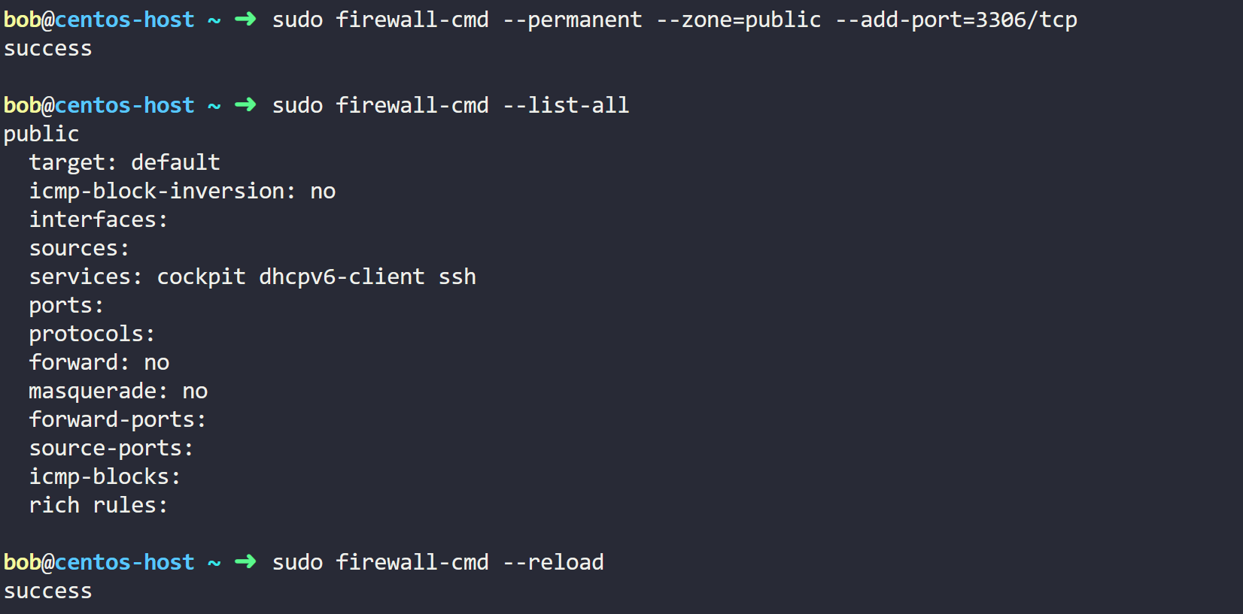 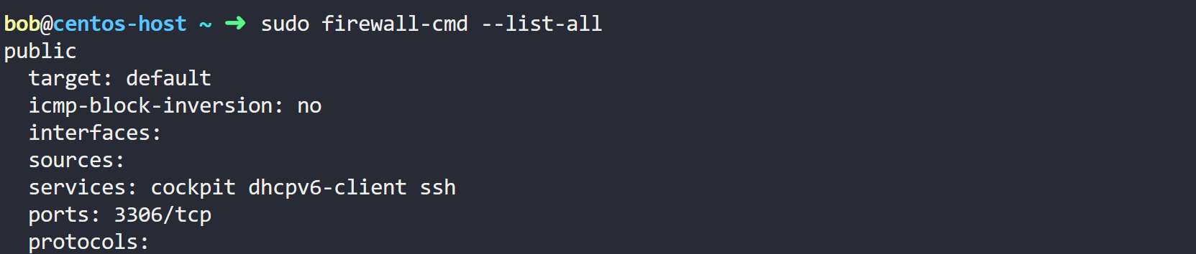

**Step – 4: Configuring Database:**

DATABASE: ecomdb

USER: ‘ecomuser’@’localhost’

PASSWORD: ecompassword

PRIVILEGES: ALL PRIVILEGES ON *.* TO ‘ecomuser’@’localhost’

**Note:** Run **sudo mysql** to open MYSQL Shell. ON a multi-node setup remember to provide the IP address of the web server here: 'ecomuser'@'web-server-ip'

**Commands:**

Run **sudo mysql** command to get into MYSQL shell then run below commands (in capital alphabets). Commands in Bold to be written in MYSQL shell.

MariaDB > **CREATE DATABASE ecomdb;**

MariaDB > **CREATE USER 'ecomuser'@'localhost' IDENTIFIED BY 'ecompassword';**

MariaDB > **GRANT ALL PRIVILEGES ON *.* TO 'ecomuser'@'localhost';**

MariaDB > **FLUSH PRIVILEGES;**

**exit**

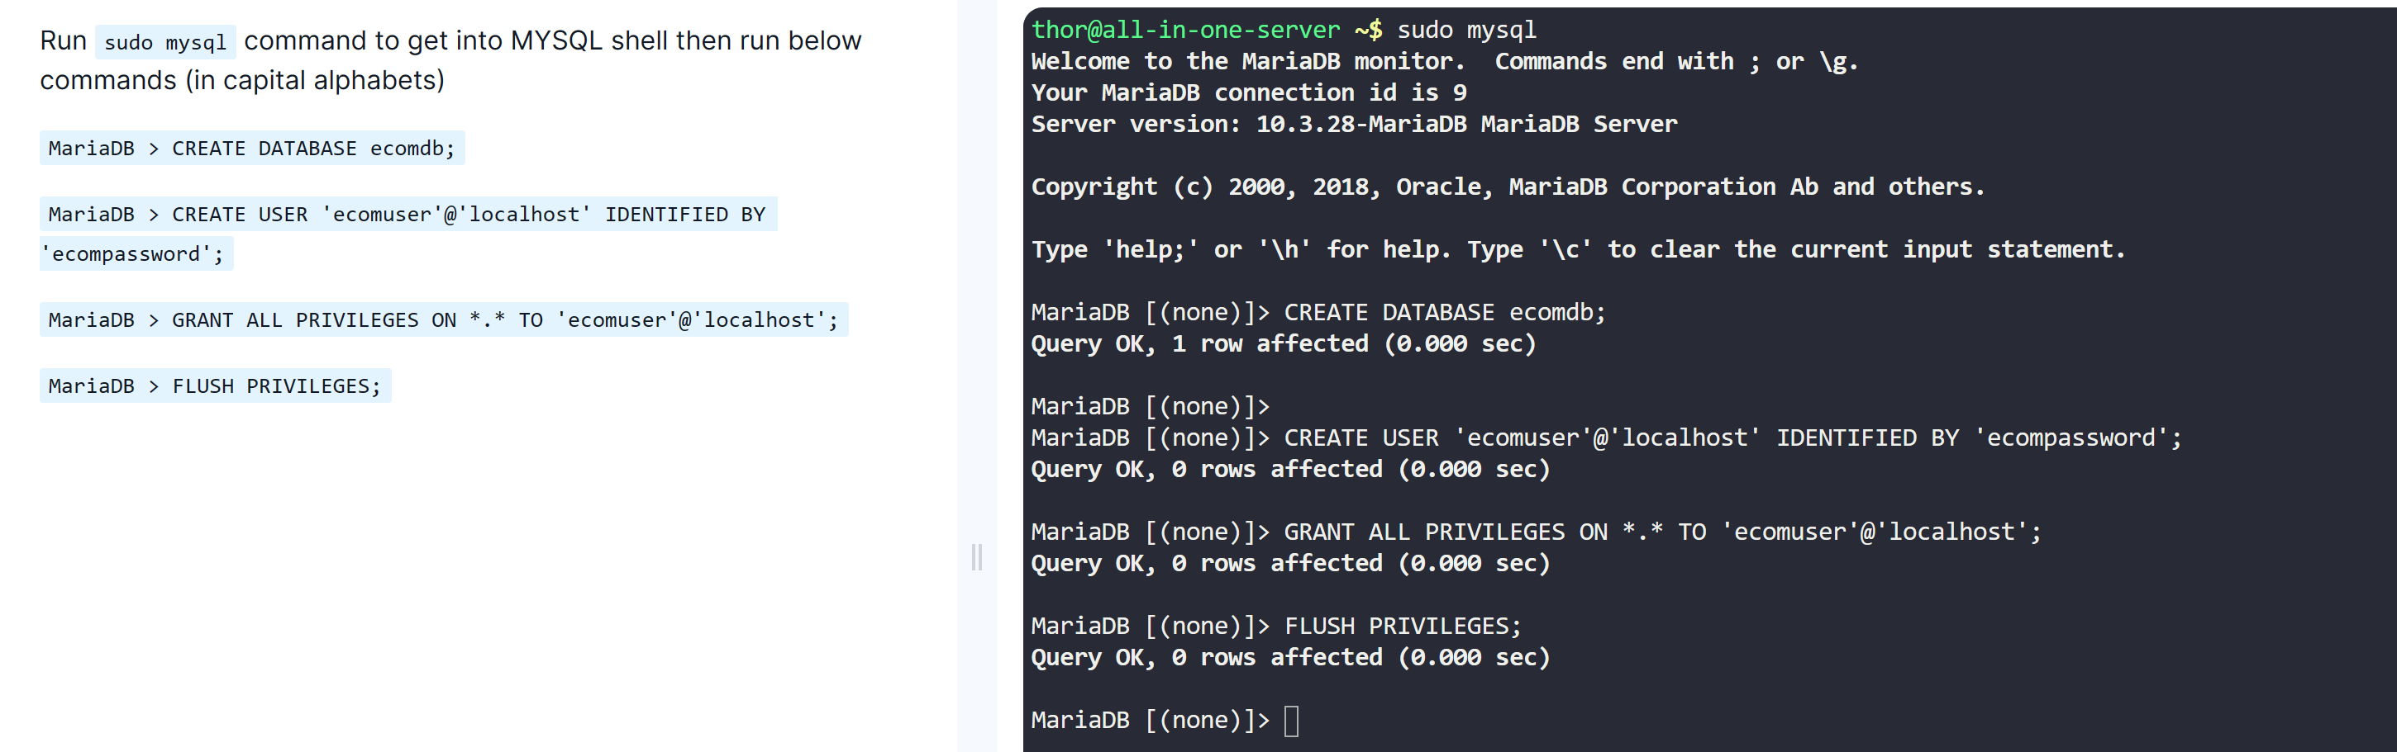

**Step – 5: Load Inventory Data.**

When the application is up and running, it needs to show data. This is that Inventory data, we have to load to database. Product inventory information is available in the assets directory with name db-load-script.sql. Load that file in MySQL.

**Commands:**

cat > db-load-script.sql <<-EOF (After entering this command, copy and paste all the below)

USE ecomdb;

CREATE TABLE products (id mediumint(8) unsigned NOT NULL auto_increment,Name varchar(255) default NULL,Price varchar(255) default NULL, ImageUrl varchar(255) default NULL,PRIMARY KEY (id)) AUTO_INCREMENT=1;

INSERT INTO products (Name,Price,ImageUrl) VALUES ("Laptop","100","c-1.png"),("Drone","200","c-2.png"),("VR","300","c-3.png"),("Tablet","50","c-5.png"),("Watch","90","c-6.png"),("Phone Covers","20","c-7.png"),("Phone","80","c-8.png"),("Laptop","150","c-4.png");

EOF

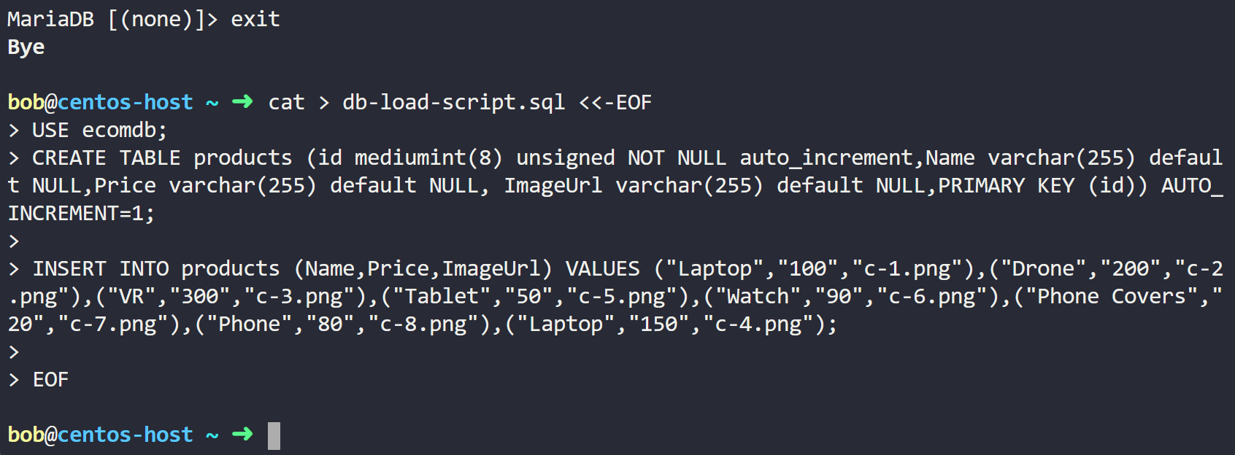

**Step – 6: Rum the sql script and Validate**

**Command:** sudo mysql < db-load-script.sql



**sudo mysql 🡪 show databases; 🡪 use ecomdb; 🡪 select * from products; 🡪 exit**

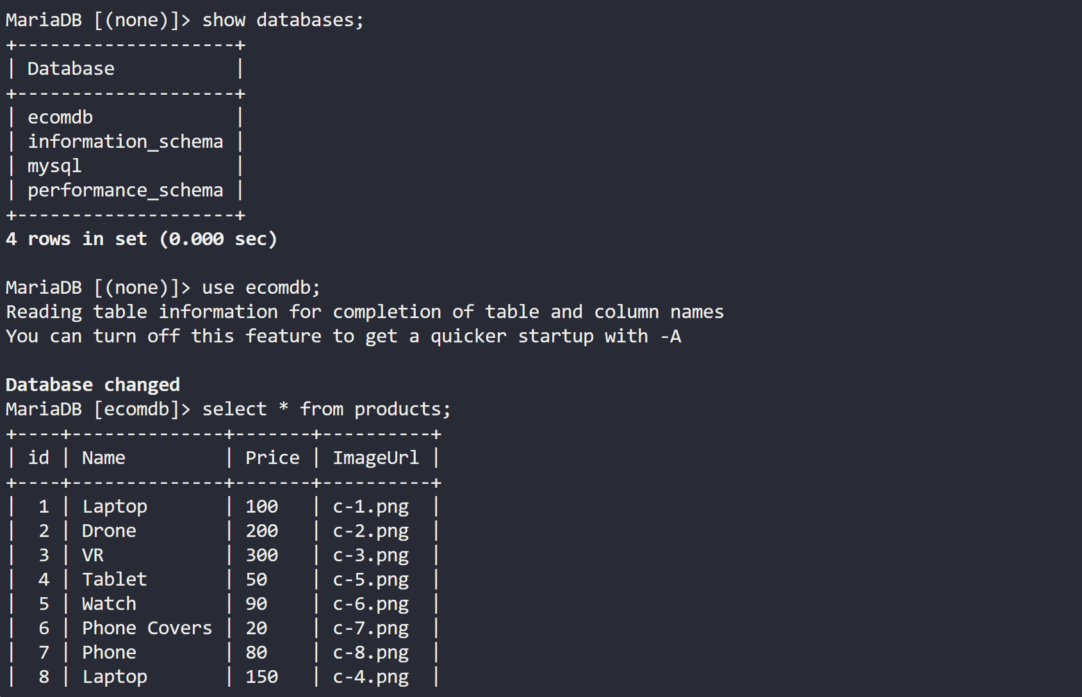

**Step – 7: Deploy and configure web server.**

1. **Install required packages:**

sudo yum install -y httpd php php-mysqlnd

sudo firewall-cmd --permanent --zone=public --add-port=80/tcp

sudo firewall-cmd –reload

sudo firewall-cmd --list-all

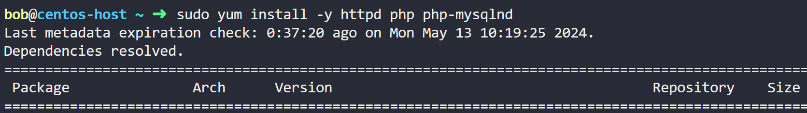 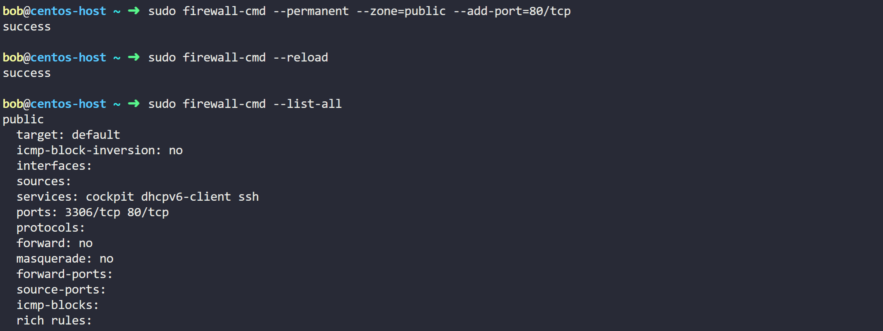

1. **Configure httpd:**

Modify the Configuration in the httpd.conf file. This is where we actually configure httpd to use the index.php file instead of the index.html file.

**Command:** sudo sed -i 's/index.html/index.php/g' /etc/httpd/conf/httpd.conf 

1. **Start httpd:**

**Command:** sudo systemctl start httpd 🡪 sudo systemctl enable httpd 🡪 sudo systemctl status httpd 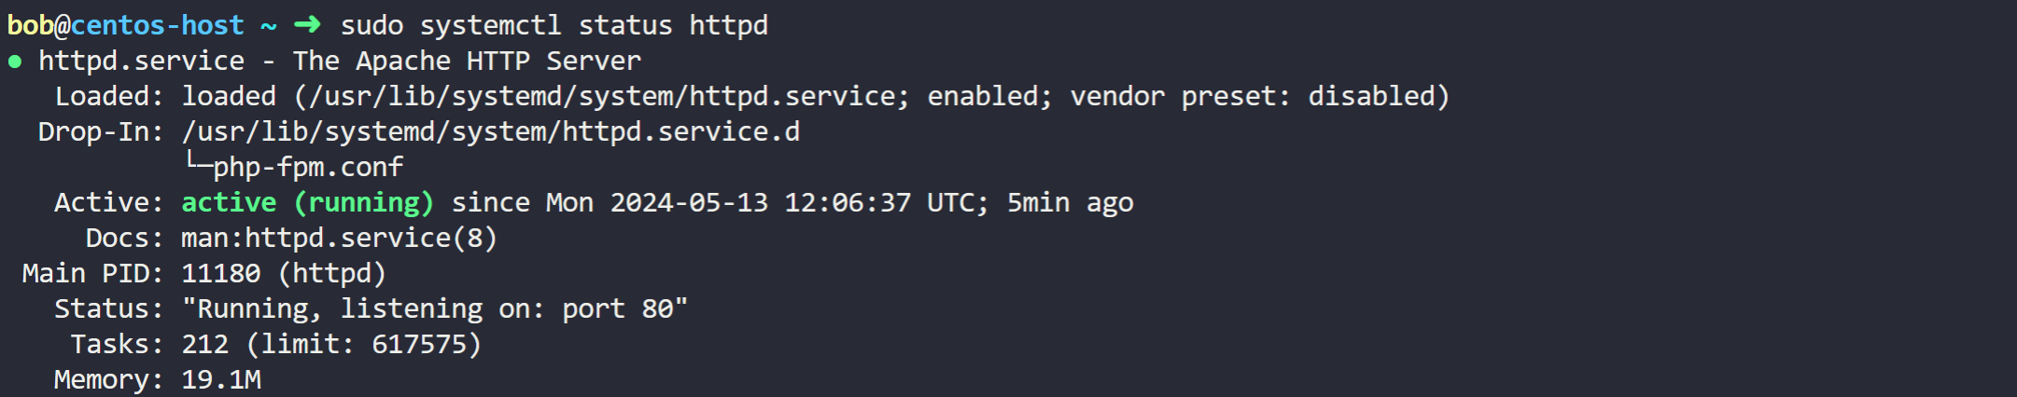Server is up and running, let’s check again in another way, checking in browser using curl command.

Command: **curl http://localhost** 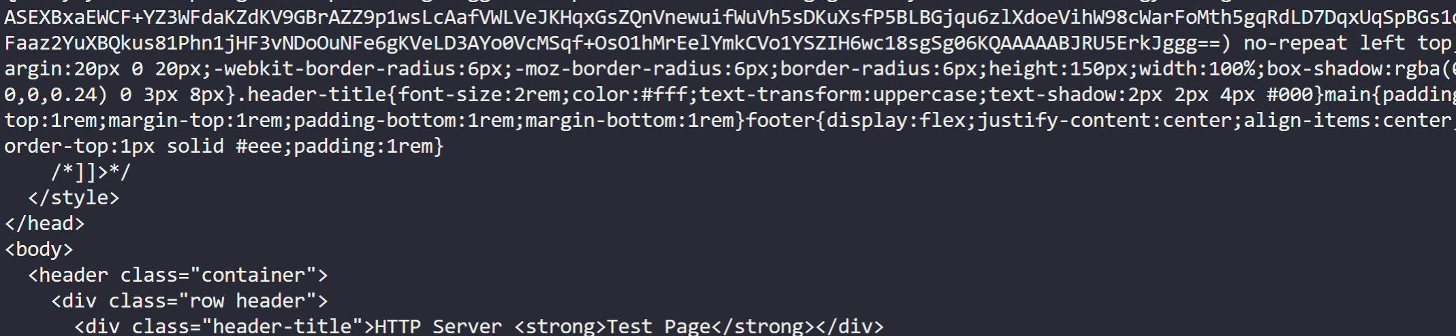

Click on View Port 🡪 80 🡪 Open Port

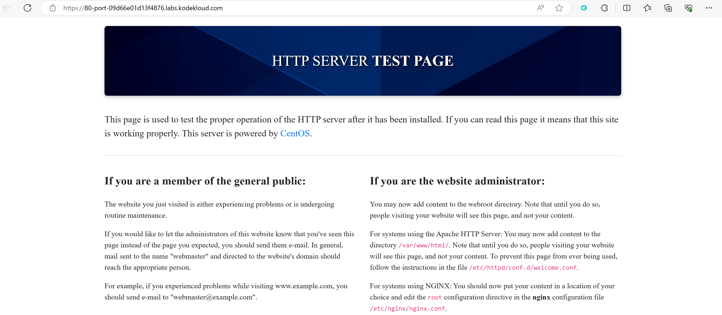This is the default page that httpd is hosting. But, this is not the page that we wanted https to host. It needs to show our e-commerce application.

1. **Download code:**

**Commands:**

git -v (If git is not there then have to install it)

sudo git clone https://github.com/kodekloudhub/learning-app-ecommerce.git /var/www/html/

cd /var/www/html 🡪 ls

  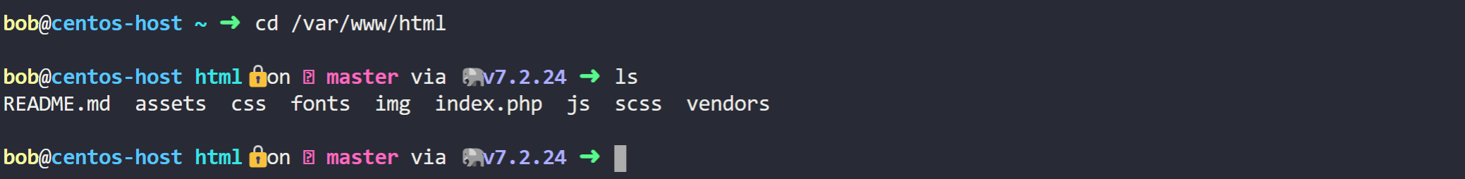

1. **Update index.php**

Update the index.php file with the right IP address of MYSQL database server. In this case **localhost**, since the database is on the same server. Before doing this change let’s see how the application works once. **Command:** curl http://localhost 🡪 Click on View Port 🡪 80 🡪 Open Port

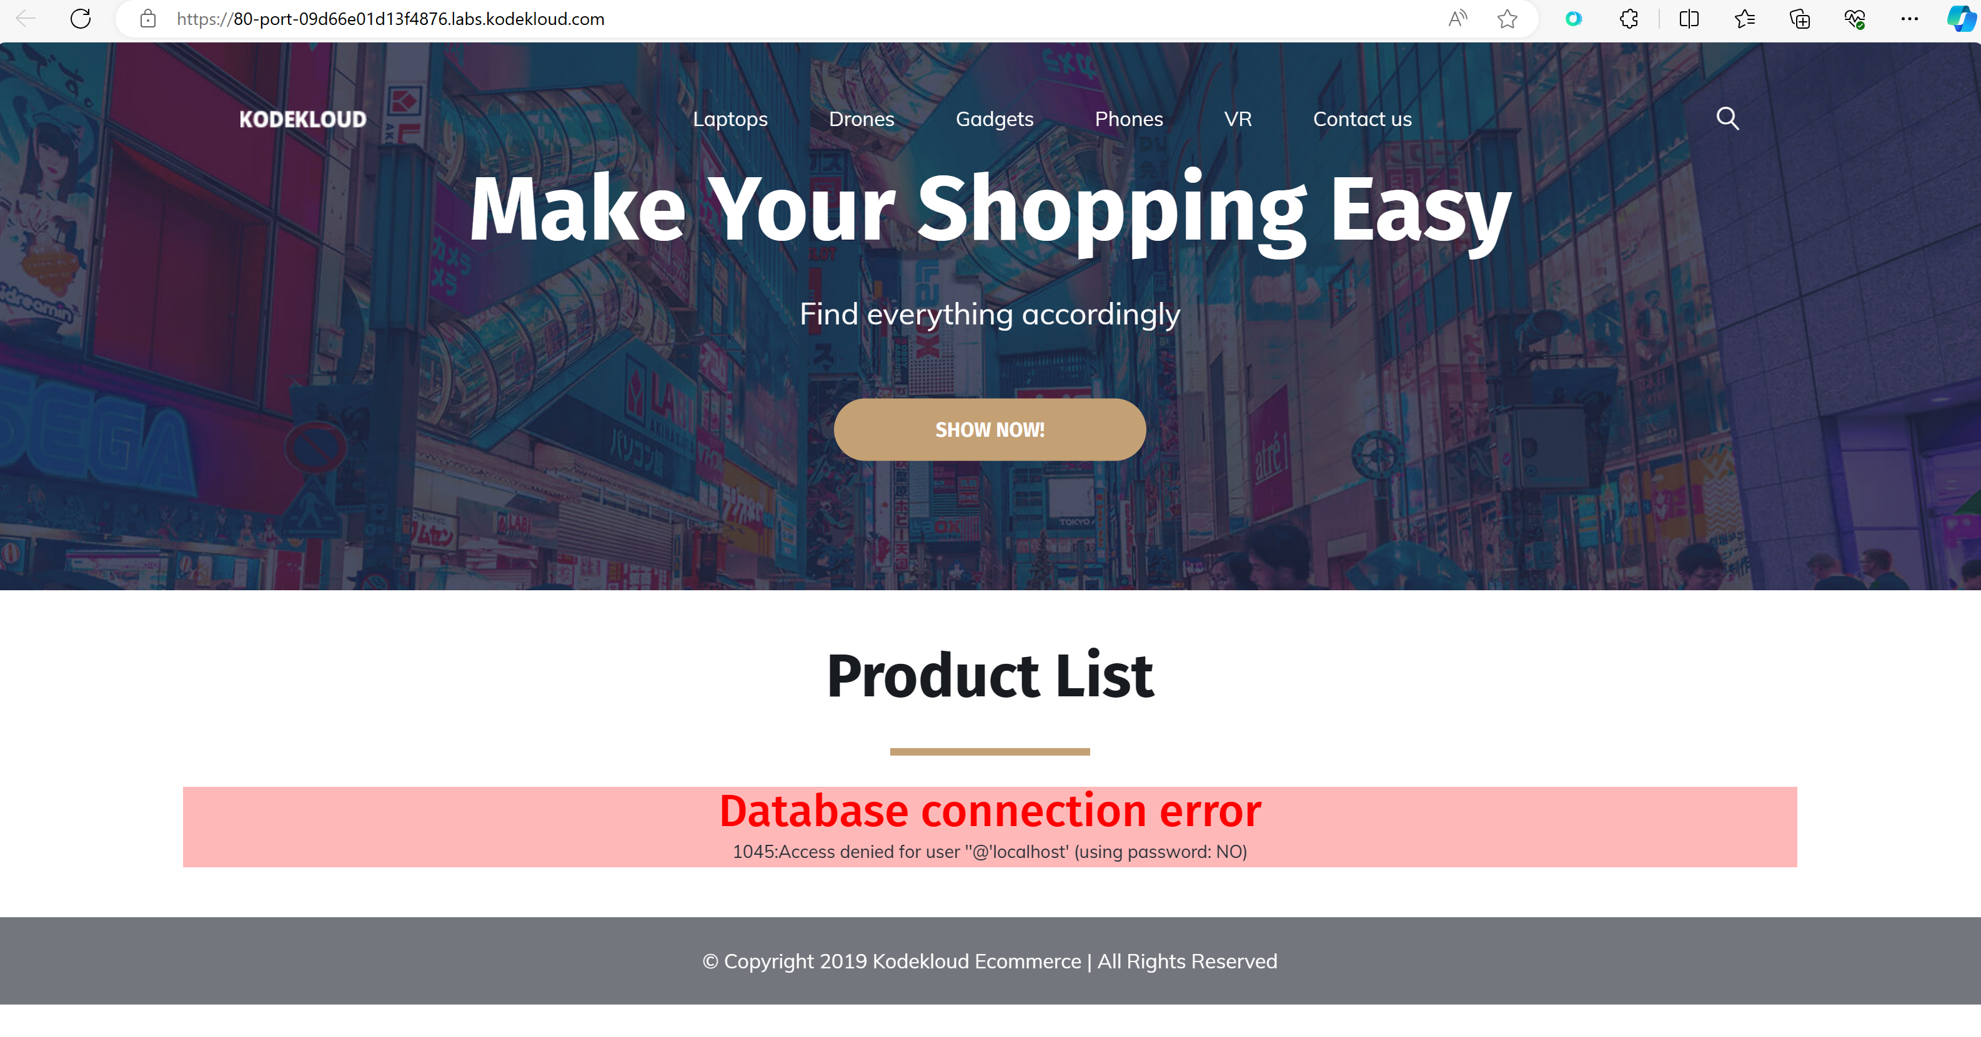

We are getting DB connection error. We have to modify the file now. This part of the file needs to be changed. Currently it is like this: 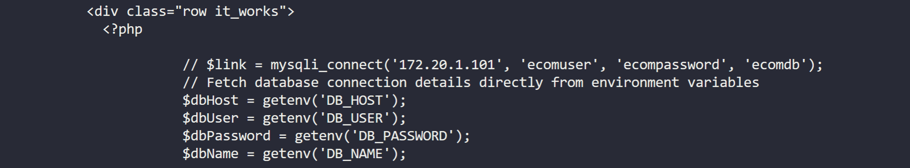

Give this **command:** sudo sed -i 's/172.20.1.101/localhost/g' /var/www/html/index.php

**Note:** ON a multi-node setup remember to provide the IP address of the database server here.

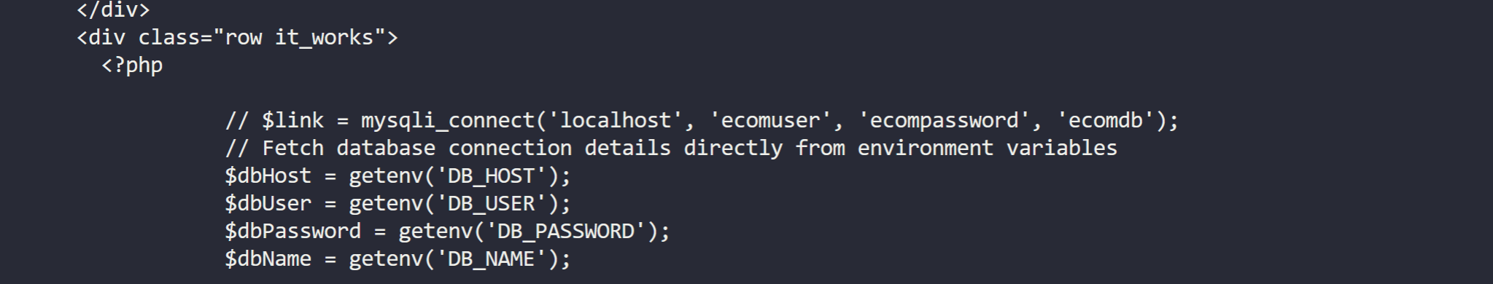

1. **Test**

**Command:** curl http://localhost 🡪 Click on View Port 🡪 80 🡪 Open Port

